# INTEL AP instructions

## General Usage

### Physical connection

* UART
* Power Adapter 12V 5A
* Ethernet cable to WAN port

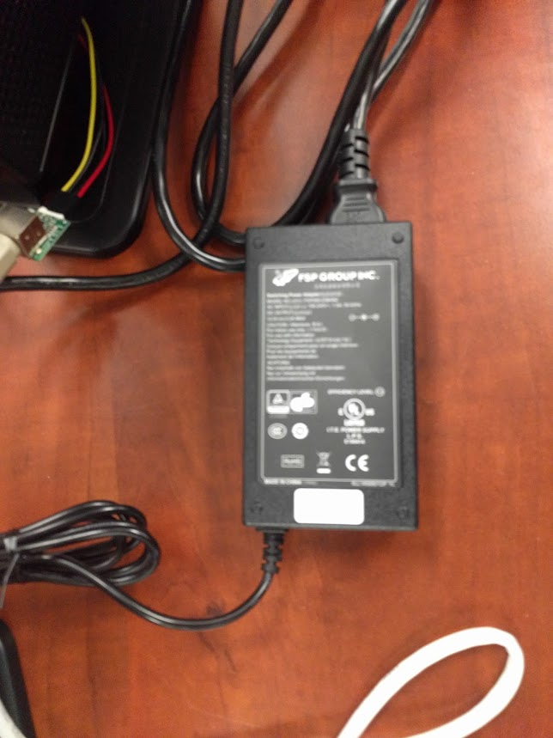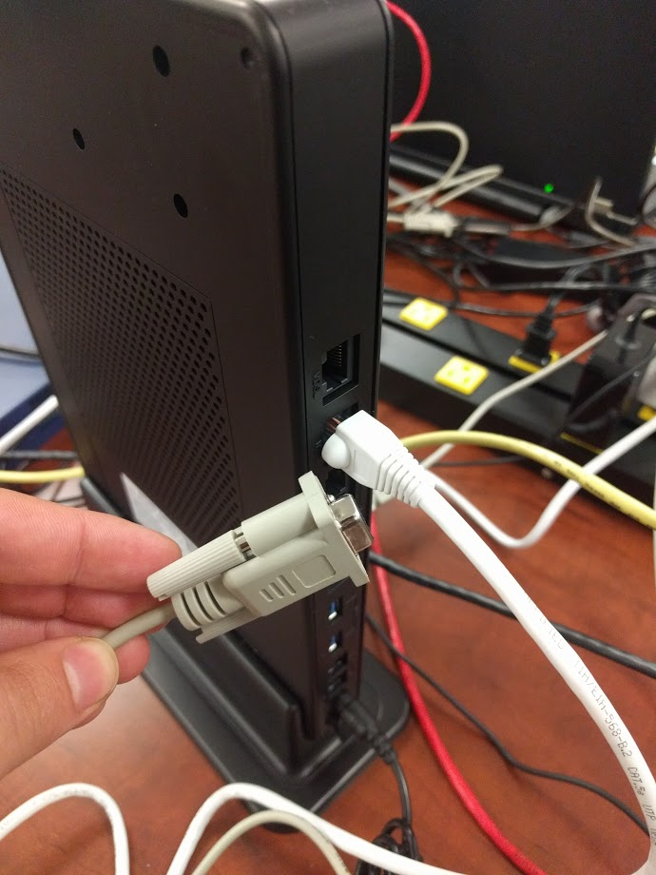

### Reboot and power up

On each reboot or power up you need to rerun the sigma agent

* User: root
* Password: admin

After reboot wait for init sequence to complete

* cd /opt/lantiq/wave/scripts/
* ./sigma-start.sh

## Advanced usage

### Flashing New Image

INTEL AP image consists of two parts

* FW image (fullimage)
* Sigma adaptation scripts

### To update the FW image

* Point tftp server in your local host to folder with the images
  + E.g. “/Testbed SW and UserManuals/Intel/AP/GRX550_CV”
* Connect the device to UART port (speed 115200,8N1)
* Reboot the device and press enter to enter Uboot
* In uboot console run
  + set serverip <ip of host machine>
  + set ipaddr <device ip default is 192.168.1.1>
  + saveenv (to flash the settings)
  + run update_fullimage
  + reset

### To update sigma scripts

* Point tfp server in your local host to folder with the sigma scripts
  + E.g “/Testbed SW and UserManuals/Intel/AP/WFA_Sigma_Test_Suite”
* Connect to the AP device and run from console
  + cd /opt/lantiq/wave/scripts/
  + ./sigma-update.sh <host ip>
* After fullimage update, you need to download sigma-update.sh first. The full sequence is:
  + cd /opt/lantiq/wave/scripts/
  + tftp -gr sigma-update.sh <host ip>
  + chmod +x sigma-update.sh
  + ./sigma-update.sh <host ip>

### Factory reset

Factory reset required mostly in two cases

* After FW image update
* If the device behaves unusually

Steps to preform factory restore defaults

1. Connect to device by UART
2. Run from the console
   1. rm -rf /overlay
   2. factorycfg.sh
   3. wait until the device reboots
   4. Update sigma scripts again

**IF YOU ARE USING THE SAME IP FOR CTRL AND DATA, configure a unique IP on each board:**

1. after the reboot restore the ip address by running three commands from the command line:

clish -c "configure lan" -c "set interface br-lan ip <IP address e.g. 192.168.1.3>"

brctl addif br-lan wlan0

brctl addif br-lan wlan1

1. **TODO: How to set netmask**

**IF YOU ARE USING THE SAME SUBNETS FOR CTRL AND DATA, -- STOP HERE --**

**If you want to separate control and data networks, use ETH WAN configuration for the control network:**

**Switch the Ethernet cable port from WAN to LAN until the configuration is done**

If you are running the device on setup which requires different ip address for the control you will need to configure WAN port and connect the control network to WAN port.

Go to device web page by using device ip (e.g. 192.168.1.1)

Username: admin

Password: admin

From the web go to ->

Basic -> Internet

Delete the line:  PTM WAN, Proto: PPPoE

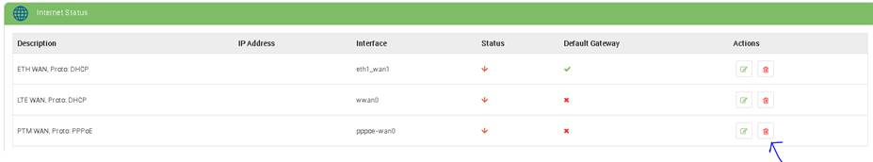

Then edit the line:  ETH WAN, Proto: DHCP

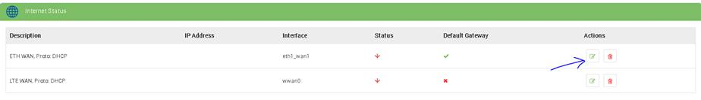

You will enter this page:

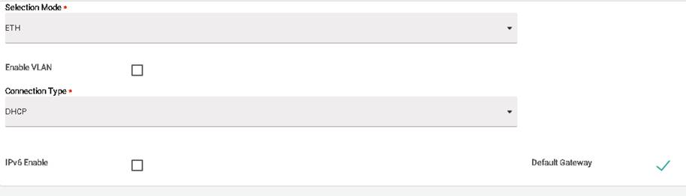

Change the connection type to STATIC and configure:

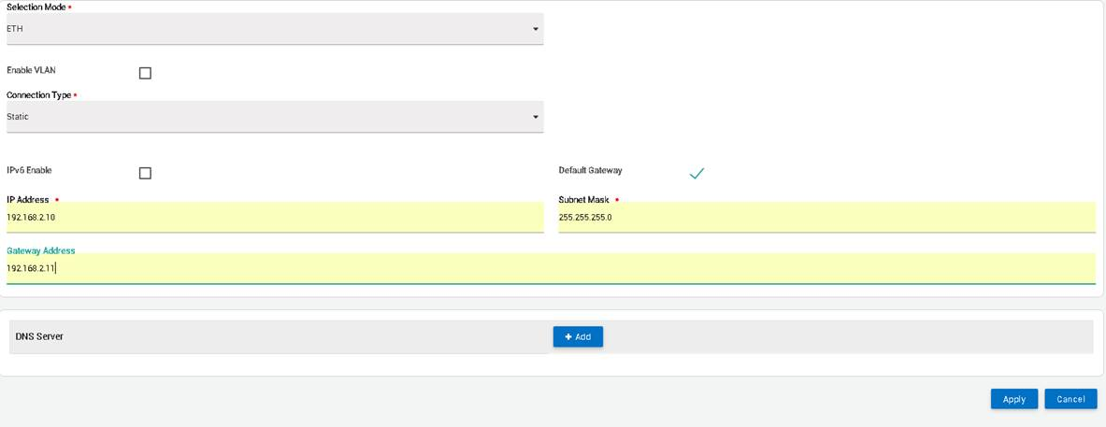

Press Apply and wait. You will be sent back the previous screen:

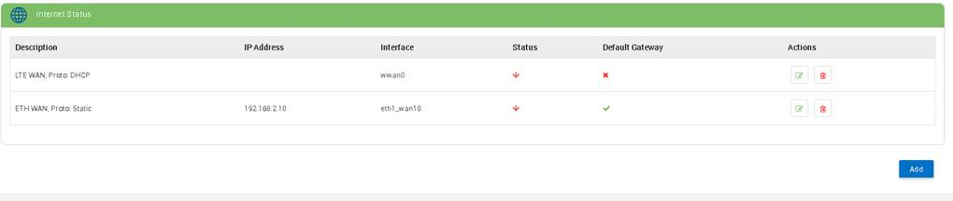

Now, go to Advanced ->  MultiCast:

At the IGMP Proxy and the Snooping boxes (Only them) and press Apply:

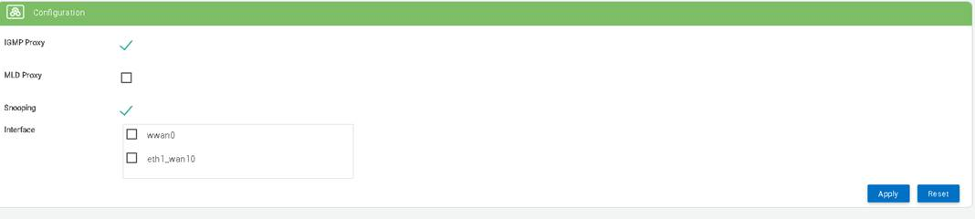

Reboot the device

### FT tests (4.2.6, 5.2.6)

To pass fast transition tests you need to configure both AP1 and AP2 mac address.

You will need to make this change if changing the device MAC addresses from u-boot, or if using a new device.

Edit the sigma-ap.sh script and upload to both AP’s

* Get the mac address of AP1 and AP2 by running in the serial console
  + ifconfig wlan1
* Go to folder the has the
  + E.g “/Testbed SW and UserManuals/Intel/AP/WFA_Sigma_Test_Suite”
* open sigma-ap.sh in text editor
* In line 37 you will see two mac variables
  + AP_MAC1=00:09:86:86:86:70
  + AP_MAC2=00:09:09:09:86:70
* In the scripts Set AP_MAC1 to hold the mac of one AP and AP_MAC2 to hold the mac address of the second device
* Upload the updated sigma script to both devices by
  + Pointing ftp server on the host to the folder with the updated script
  + On the device running
    - cd /opt/lantiq/wave/scripts/
    - tftp -gr sigma-ap.sh <PC IP Address>
    - ./sigma-start.sh

# Reference configuration

You can find reference configuration that was used in our setup for AllInitConfig_MBO.txt at:

“/Testbed SW and UserManuals/Intel/AP/WFA_Sigma_Test_Suite”

LAN

* For AP tests (4.x) use
  + AllInitConfig_MBO-AP.txt
* For Station tests (5.x) use
  + AllInitConfig_MBO-STA.txt – for Station tests

WAN

* For AP tests (4.x) use
  + WAN-AllInitConfig_MBO-STA.txt
* For Station tests (5.x) use
  + -AllInitConfig_MBO-AP.txt